97 Princess Victoria Street
Clifton, Bristol BS8 4DD
12 April 2012
To: Graham Groom
Transport and Works Act 1992
Ashton Vale to Temple Meads and Bristol City Centre Rapid Transit Order
Statement of the Bristol Industrial Archaeological Society (BIAS) for the public inquiry starting 22 May 2012.
Argument Summary
- Lack of contact from Councillors, and Council to make the public aware of the details of the Public Inquiry
- Application included unnecessary expensive adaption work to three grade II listed bridges when it would be better to spend money maintaining them. Demonstration of total lack of regard of industrial heritage. Only on 21 March 2012 did they revise some of their ambitious applications which show lack of forethought, but this was only on cost grounds.
- Confirmed negative impact (report to Cabinet Appendix C July 2011) on the Harbour Railway, the dockside heritage and M Shed which has just had a very expensive makeover and is very popular. Visitors enjoy the experience travelling on the steam train especially when it goes to the Create Centre along a very scenic route and it should be operated more often rather than less often. Tracks retained for seasonal Sunday services and infrequent events. Currently it runs on Saturdays, Sundays and Bank holidays 40 days a year. Demonstration of total lack of regard of industrial heritage and the tourist experience.
- The only positive impact confirmed (report to Cabinet Appendix C July 2011) are that the railings alongside the Cumberland Road will be restored (except that Appendix D shows that there will be an adverse effect since the railings will be shorter); existing signage on Prince Street to be removed (except that most is still needed due to bridge swings and a one way system and there will now be a massive clutter of 40 metre bus stops ruining a historic view adjacent to grade II and grade II* buildings!); and theoretical restoration of the Ashton Bridge which would have meant removing evidence of its rare top structure!
- An unproven financial viability when it appears there are currently less buses running along this route than there used to be, and Long Ashton Park and Ride closing earlier. It is by no means certain that the new football stadium will be built (which is in the same area as the current one anyway).
- Problems caused to car drivers and traffic flow by closing Prince Street Bridge to them.
- Emergency vehicles will no longer be able to use Price Street Bridge.
- Problems caused to the heritage of Prince Street by making it a major route for all rapid transit vehicles. This street is closed when events such as the harbour festival takes place since there are too many pedestrians so the rapid transit would not be able to operate either.
- Problems caused to the Rapid Transit if they can not cross Prince Street Bridge because it opens once per hour during busy times. English Heritage have confirmed that this listed bridge must continue to operate.
- Loss of coach park and parking in Cumberland Road. (Appendix 6). There is surprisingly little long stay coach parking space available considering how many tourists visit Bristol. There are only 90 spaces over 5 sites and 12 would be lost here.
- Problems caused to traffic flow along the Cumberland Basin caused by massive 40 metre bus stops and getting stuck behind a bus. The SS Great Britain bus stop is 225 metres from the Gas Ferry Road (another 175 metres to the ship) as it is governed by the location of Vauxhall Bridge! The 506 bus has a stop in Gas Ferry Road for the SS Great Britain!
- The more one looks at this scheme, the worse it gets.

Public Inquiry
- It has been very difficult to find details about the inquiry. Why is there not a clear web page on the transport section of the Council site giving details? I have been to 2 public inquiries before and was told the details personally about how submit a comment.
- As a member of the committee of the Bristol Industrial Archaeological Society, and resident of Clifton in Bristol, I wrote a statement to the Council Cabinet Meeting 1 September 2011 (Appendix 1) to protest against the effect that this scheme would have on the heritage railway and the Cumberland Road, as well as increased traffic on Hotwell Road and Coronation Road. The response from Tim Kent (Appendix 2) does not answer our concerns.
- I also asked my councillors Barbara Janke, and Trevor Blythe as well as Tim Kent to reconsider their party’s support for it on 24 March but received no answer. They did not even tell me the details about the Inquiry even though I asked. I can only assume that the Council do not wish the Inquiry to be made too public.
Bridge Adaption
- It is a waste of valuable public transport funds – requiring expensive adaptation work to all three bridges (£2,480,000) in the Harbour Conservation area and construction of a new bridge over the Portishead rail line. There are better ways of spending £49m (£12m from Bristol and businesses, £5m from Somerset). The bridges need maintenance but not damaging adaption work. It would be better to spend some of the money Bristol has put aside for their maintenance.
- Prince Street swing Bridge is grade II listed bridge. Listing details: Swing bridge, quay walls and engine house. 1879. Iron, Pennant rubble with limestone dressings and slate hipped roofs. Riveted steel plates to the arched sides and deck, with 2 carriageways, stone abutments, capstans and bollards Application 11/02491/LA submitted June 2011 (decision pending). Strengthen and realign. No costings given. The bridge can swing every hour in busy times which would delay the rapid Transit schedule. English Heritage would only consider granting permission if the bridge can still swing. It would be cheaper and less damaging just to maintain the bridge, not to remove deckways structure. The east carriageway needs to be made wider, the footway needs to be raised to 200mm and the west footway will be removed so there will be clashes with pedestrians and cyclists. Additional lateral stiffening bars now needed on the outside of Prince St Bridge according to revised plans of March 2012. Note the current limit is 3 tons since the 20 year old replacement beams have failed. A small single decker bus weighs 6 tons unladen, a bendy bus 28 tons. The bridge has been assessed to support 40 ton. There will be significant work to make this bridge strong enough, and may have an effect on swinging in the future due to realignment.
- They state the advantage of doing the work is Removal of existing signage and other street clutter! This will be replaced by more clutter of huge platforms on Prince Street and bus barriers!  - The clutter of off bus ticket machines now does not appear to be applicable since in the revised scheme there will be none but will mean that it takes longer to get on the transport since many people will not have bought a ticket in advance. Ticket checkers will have to be employed to avoid delay and fare evasion  - Apparently the majority of platforms are now typically 18 metres in length by 3 metres in width which can comfortably accommodate around 150 people waiting for a rapid transit vehicle. I have never seen 150 people waiting for a bus unless perhaps during the balloon festival!  - The two massive 50 metre bus stops will be just beyond this bridge by the Arnolfini and historic bridge buildings. Massive clutter in a sensitive, quiet historic street adjacent to grade II* and grade II listed buildings.  - 60 rapid transit vehicles per hour, platforms for 600 people???!!! Nightmare and unrealistic. Only light traffic uses it now.  - Emergency vehicles will no longer be able to use it  - At festival times Prince Street is closed to traffic since there are so many crowds all over the harbour and Queens Square. What happens to the rapid transit then? | - Traffic lights for motorists, bollards, weak bridge, 3 ton weight limit, 7'6" wide, pedestrian sign, road markings, flashing lights for bridge swings, barriers for bridge swings. Most will have to be kept since there will still be bridge swings, a pedestrian side and buses will still need the traffic lights as it will still be a one way system.  - Thus it can not be true to state that existing signage will be removed. The only one that can be removed is the weak bridge sign.  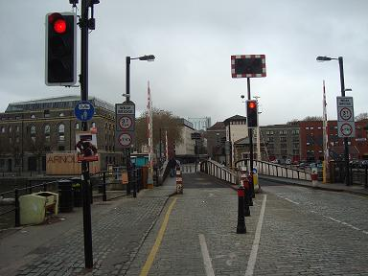
- Grade II* Arnolfini and grade II engine house  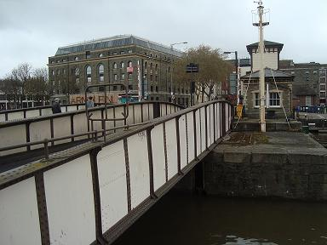 | 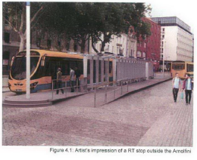  - Clutter of barriers and a massive 40 or 50 metre two sided bus stop adjacent to the grade II* Arnolfini and other grade II docks buildings and cobbled roadway virtually filling up the whole of this currently open uncluttered space. The guideway cannot handle corners and sharp curves and will find it hard to sweep into Prince Street and Grove Road. The journey will be neither rapid nor smooth (especially on cobbles) for passengers on a double decker or articulated bus.
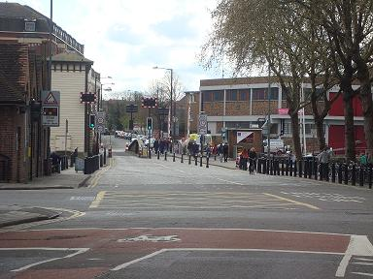  The bollards will stay. The rest of the cobbled area will now be covered with a masive double bus stop next to the historic engine house. Massive clutter in a sensitive, quiet part of a historic street adjacent to grade II* and grade II listed buldings. | - Plenty of buses around using Grove Road. Why more?  - Note the uneven cobbles.  - 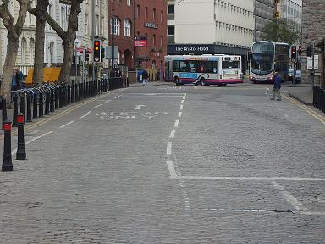
- Vauxhall Bridge is a grade II listed pedestrian bridge. Listing details: Swing bridge across River Avon. 1900. Superstructure built by Lysaght's. Hydraulic gear by Armstrong Whitworth. Pennant rubble and steel. Square pier on S bank of New Cut, with cutwaters separated by an arch at the bottom, carrying a round drum and lattice swing bridge, which tapers towards the north bank. Application 11/02492/LA submitted June 2011 (decision pending) - lift by 350mm. No costs given. Bristol City Council plan to undertake emergency repair works that will ensure that the bridge is fit for purpose. However, even following the completion of these works, there is no guarantee that it would be possible to raise the structure (Halcrow report). It would be cheaper and less damaging just to maintain the bridge. On 21 March 2012 plans were revised and this application has apparently been withdrawn. It is hoped that repair will still take place!
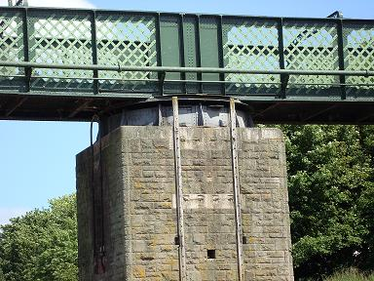 | 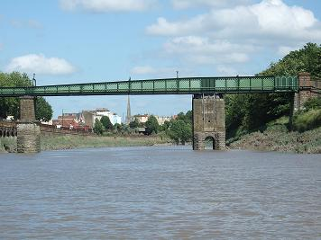
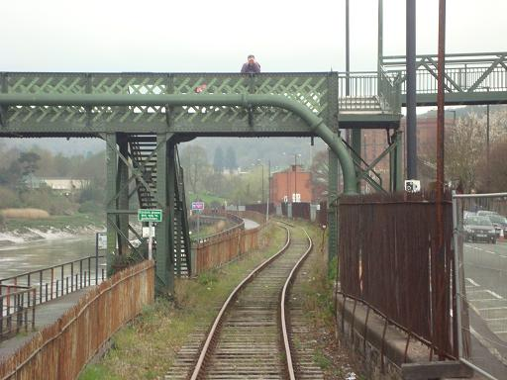 | - Regard the large pipe along the bridge.  - We can not believe that an application would be put in to lift this bridge knowing that it may not be possible. All the pedestrian bridges are well used.
- Ashton Bridge grade II listed. It is an unusual example of a combined road/rail swing bridge (now fixed). 1905-6 for Bristol Corporation and the Great Western Railway, chief engineer J.C.lnglis, contractor John Lysaght and Co of Bristol, hydraulic machinery by Armstrong Whitworth and Co. Steel, with squared rock faced limestone abutments. Two piers with the southern one supporting the swinging apparatus. Enormous Whipple Murphy truss swinging span weighing some 1000 tons which carried a double track line to the north bank of the Avon New Cut thus opening up the south side of the Floating Harbour to rail traffic as well as the north bank via the Cumberland Basin bridge. Application 11/02494/LA submitted June 2011 (decision pending) Adaptation, alterations to the deck and incorporation of new attached bridge structure for pedestrians and cyclists. £400,000 (excluding the cost of the new bridge which will not now be required) on top of the repainting and restoration costs of £800,000. Removal of top deck supports showed a blatent disregard for the bridge design and may well weaken it. It would be cheaper and less damaging just to maintain the bridge.
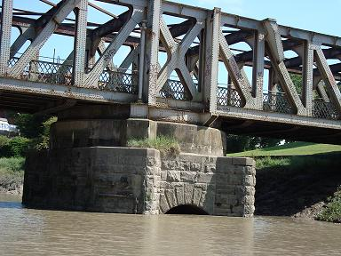 | 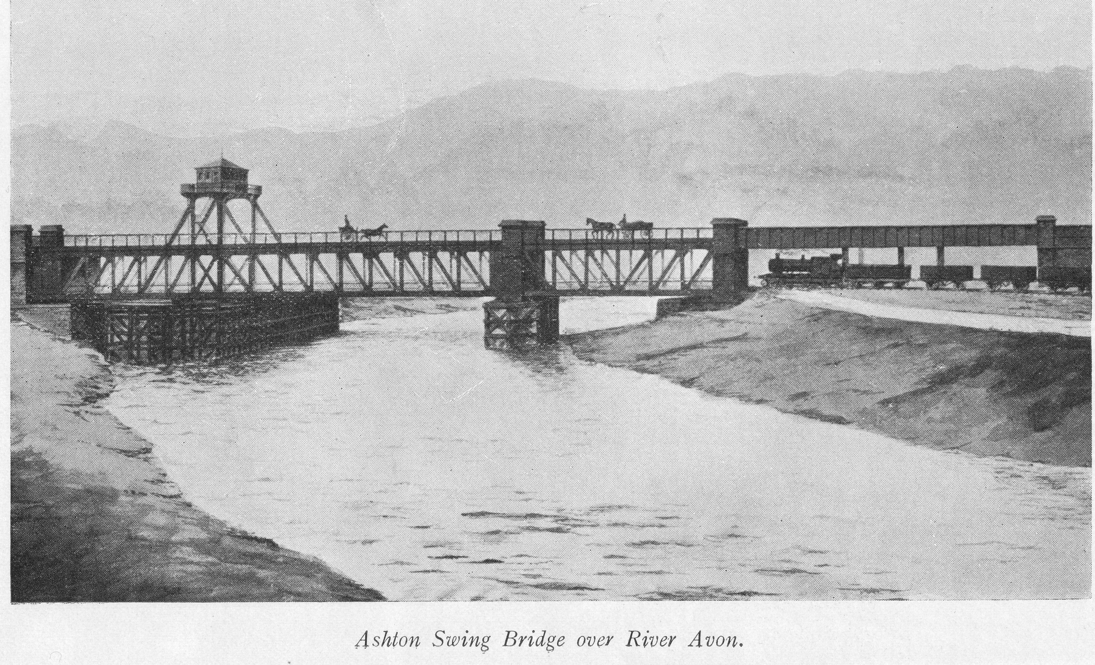  - Picture clearly shows the railway below and other transport above
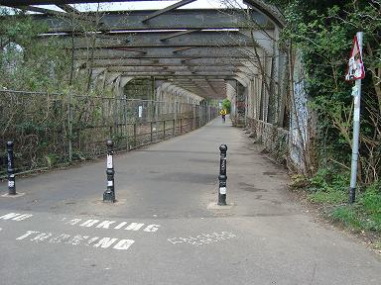 | - It looks very sad today, but to even contemplate removing upper supports, and to make the bridge for buses only, resulting in an extra bridge for cyclists and pedestrians shows a total lack of regard for heritage and landscape. The revised scheme now means that both buses and cycles using the same bridge with shuttle working of BRT (under traffic signal control) across the bridge; but how this will work in practise? The railway currently stops just before this bridge (not shown in map 111)
- Cumberland Road bridge now needs a trough underneath to increase the headroom for the BRT. This means that the route will be under the flood level thus increasing a risk of flooding in this area.
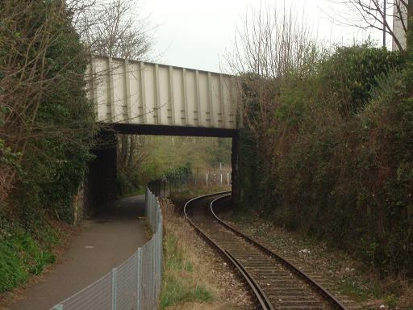 | - This part of the track needs to be lowered by .7 metres to get the BRT bus under the Cumberland Road. It will then get flooded so extra flood defences have to be built.

The Harbour Railway
- This evidence has been written after consultation with some of the volunteers including Roger Davis who is the secretary of BIAS. They are all concerned about the future of the railway. The revised plans of March 2012 demonstrate how cost savings have been achieved, and it may well be that the proponents of the scheme may well decide that they can not afford to do all the changes to enable the harbour railway to run along the Cut any more.
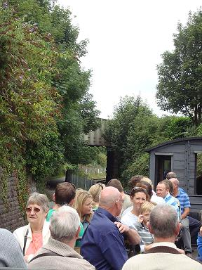  - A trip through valuable semi-rural, wild areas with the Portbury or Henbury | - .  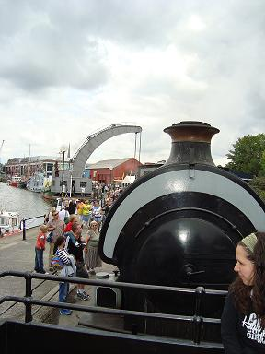  Portbury with eager customers. Steam crane in the background
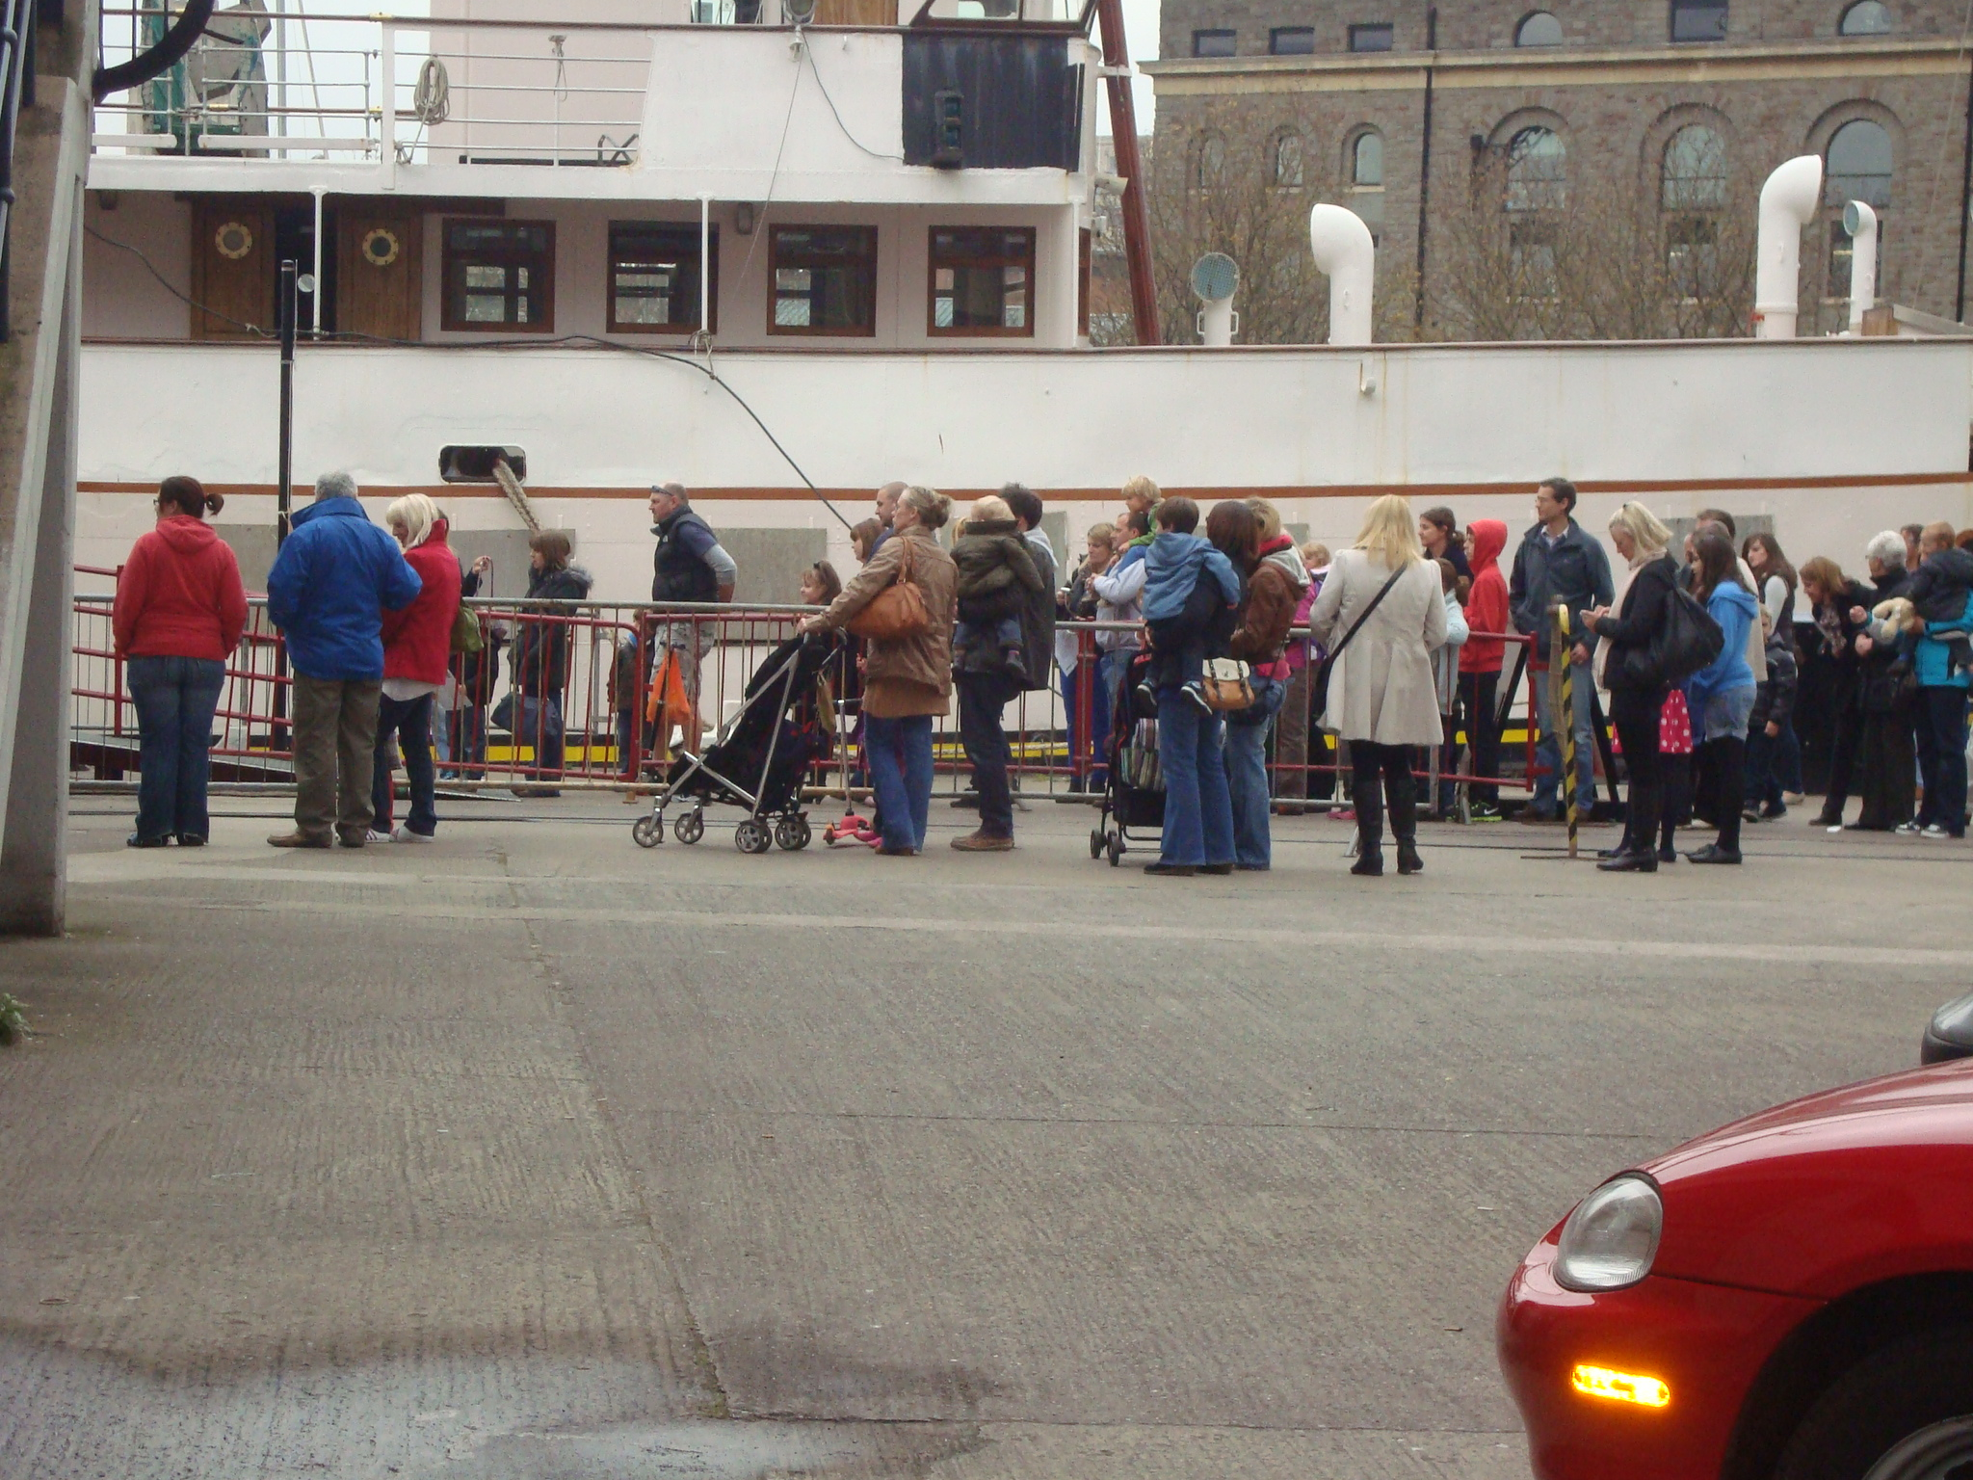  - Big queue of people waiting for a ride young and old | 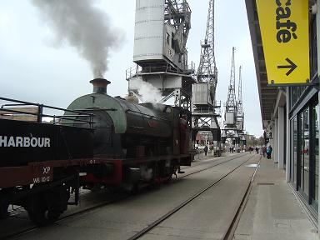  - Henbury right outside M Shed, cranes in the background
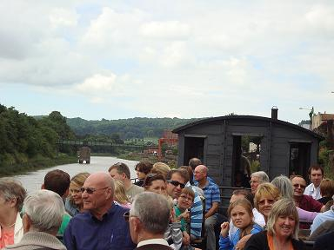  - packed full of happy customers travelling past the Cut | 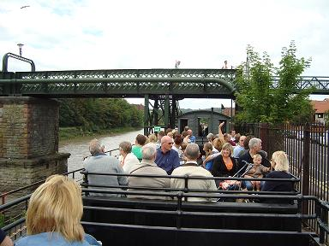  - Waving at pedestrians, and the pedestrian waving back. Everyone loves the railway
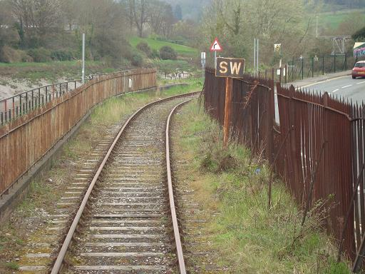  - Sound the whistle- a very evocative original scene marred by a glorious mishmash of railings, many original. There is an application to demolish the railings and replace by wall and short railings (Appendix 4) | 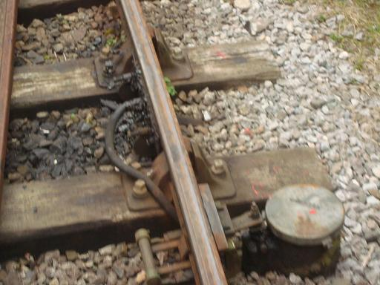  - There needs to be regular automatic greasing points for the engines. Grease will play havoc with the BRT wheels
- In 1978, the preserved railway was established as an element of Bristol Industrial Museum (now M Shed) using locomotives built in Bristol and formerly used at Avonmouth Docks. At first, it only connected the Museum with the S.S. Great Britain but when commercial rail traffic ceased, the museum railway was expanded in 1995 to use the branch alongside the New Cut. When the Portishead Railway was relaid the connection at Ashton Junction was severed. There is one mile and a half of track to the Create Centre, three quarters of a mile to the Great Britain
- The steam trains run from outside M Shed and along the docks to the SS Great Britain or as far as B Bond Warehouse (home to the Create Centre and Bristol Record Office). On the south side of the harbour the railway crosses Spike Island, the narrow strip of land between the Harbour and the River Avon, and clings to the side of the river as far as the junction with the northern branch at the Cumberland Basin. A glorious mixture of scenery.
- It runs on various Saturdays, Sundays and Bank Holiday Mondays from 24 March until the autumn. In Easter 2012 Henbury will run every 40 minutes between 11am-5pm on all three days so the Council to state that it will run infrequently on some Sundays means that this experience will now be reduced. It can carry 90 passengers at a time and usually takes £1,000 per day so covers its running costs. It runs alternately to the SS Great Britain and to the Create Centre. The days should be increased to take advantage of the increased number of visitors to M Shed. The current flier for rides on boats, cranes and trains is included in Appendix 5 and shows very clearly that it runs on both Saturdays and Sundays and that it is run more than the other items. On average it runs on 40 days a year.
- It uses three wagons adapted to modern regulations for passenger use. It usually uses one truck that can hold 40 people sitting, one truck with 20 people, and 10 in the goods wagon. There is plenty of room for push chairs and it can take disabled chairs. It has other rolling stock along the track to add to the authenticity, the wagons on display representing types that were around 40 years ago
- Henbury and Portbury have pulled hundreds of thousands of visitors along the quayside. Henbury, built at the Bristol company Peckett's worked in the Bristol docks at Avonmouth in 1937. Portbury was built by the Avonside Engine Company Ltd at Fishponds, Bristol in 1917, so both local engines.
- A working steam railway helps to retain an echo of the working dock itself, along with the cranes. The Industrial Museum has always been an exceptionally popular venue for Bristolians, and a great place to take visitors to show off the docks and the city's heritage.
- The railway is part of the heritage experience for tourists and residents alike. Has no one ever watched the visitors enjoying the experience of the Portbury from M shed to the Create Centre?
- M Shed, and to a lesser extent L Shed, have been transformed by a £27m make over and was reopened in June 2011. The Heritage Lottery Fund has given £11.6m, Bristol City Council has given a further £12.1m with other support from grants and gifts. All this has been done sensitively so as not to lose that feeling of how the working dockside would have looked in its heyday of the 1950s. The refurbished electric cranes, the steam engines pulling visitors along the dock and the three museum boats taking passengers for trips around the docks are all kept alive by a team of enthusiastic volunteers some of whom have worked there for over 30 years including David Martin who runs the Harbour Railway.
- Visitor numbers to M Shed have exceeded all expectations. On 13 March 2012, just ten months since it opened, visitor numbers reached the 500,000 mark - double the anticipated number for its first year and averaging 50,000 visits per month. The heritage Railway is an extra attraction to this part of Bristol. It should be running more not less for all the extra visitors.
- Bristol City Council state that The route between the Ashton Avenue Bridge and the Museum of Bristol follows the alignment of the existing Bristol Harbour Railway. The tracks for the heritage railway will be retained to provide for seasonal Sunday services and events such as the Harbourside Festival. When these infrequent events occur, services will run on Cumberland Road. This is rather contradictory. It appears not to appreciate the role of the Railway as a part of the visitor experience to M Shed and Bristol. They appear to want the Railway to run less. They do not appreciate what a fantastic asset the Railway is.
- The Cabinet reports (Appendix C) confirm that there will be a negative impact on the Dockside, and the Railway. Indeed the only positive impact they see is refurbishment of the Ashton Gate Swing Bridge- which should be done anyway using some of the money that Bristol needs to put aside for the Rapid Transit Scheme, and removal of existing signage and other street clutter from Prince Street Bridge (which will be replaced by more clutter and be very unpleasant to cross by foot and cycle).
- BRT means the Steam Railway will run on a shorter track encased in ugly concrete tracks. It will run less frequently (Sundays only) and be less authentic and attractive to both volunteers and passengers and tourists. The whole scheme wrecks the historic heritage which attracts so many visitors to this area.
- Ominously the revised plans state that the alignment and the termination of the Harbour Railway to be determined. Map 111 only takes it to Avon Crescent.

Bitton
- The nearest steam railway to Bristol is the Avon Valley Railway at Bitton which is not exactly in the centre of a town, so all its visitors come because of the inspiring variety of events it puts on such as Learner days, and because of regularity of service. The Dockside Railway could also do events such as Learner days along the track to the Create Centre which would be very feasible and popular
- This Easter it is running Tuesday 3rd until Thursday 12th April which shows the demand- and which the Harbourside Railway should be emulating rather than only three days.
- Visitor numbers for the Santa Specials in the run-up to Christmas usually top the 10,000 mark.
- As a tourist attraction, the Avon Valley Railway now handles 80,000 visitors per year. M Shed has 500,000 and many people come when there is a special event "Take a ride on M Shed's boats, cranes and trains"
903 Park and Ride Service

It replaces the current 903 Park and Ride service which goes to the Centre via Hotwells Road and so is unnecessary. This runs every 10 or so minutes and the journey takes 15 minutes to the centre. The Park and Ride closes at 8pm and is closed on Sundays so why spend so much money on this route?

Passengers are advised that as of Monday 2nd April 2012 the evening service on the 902 Portway and 903 Long Ashton Park & Rides has been curtailed due to service issues! The last bus from the centre leaves at 7pm!
- The Park and Ride only holds 1500 cars so is not really adequate if Bristol City Council is trying to encourage visitors and commuters to use the Rapid Transit Scheme

The 506 orbital bus route was introduced on 1st April which goes from the Create Centre to Broadmead via Cumberland Road and ends up in Southmead. This only runs every 30 minutes. This replaces the 500 and 510 which used to run 20 minutes so buses are being run less frequently!
- The U1 orbital runs from Bower Ashton to Temple Meads via Coronation Road and runs every 30 minutes
- This shows that there is a wide variety of routes not necessarily being run very frequently and yet there is an anticipation that there will be 60 buses at peak hours over Prince Street Bridge. The numbers do not stack up.
- The long term financial viability of the BRT service is dependent on future passenger forecasts and passenger trip patterns which are not supported by current bus passenger behaviour. Long Ashton Park and Ride being closed on a Sunday demonstrates this! As do buses along the Cumberland Road only running every 30 minutes. It is also dependent on the new football stadium being built- which is by no means certain.
- BRT is not a flexible transport system that can be rerouted. It only possibly helps Park and Ride Visitors from Long Ashton. I found last week that it was quicker for me to walk to the centre of Bedminster than get two buses. Bus services (903,X1, 354,361) that serve Hotwell Road will be relocated to the BRT route so it will still be quicker for me to walk to the centre of Bedminster from Clifton and worse for people from Hotwells. The system is essentially one route from one side of the city to the other, with huge portions of the city left unserved and will lose integration with existing mass-transit systems. It can not even go right up to Temple Meads station but has to stop 400 metres away so does not even help those people who are trying to get to the station using public transport.
- The railway is better left a railway for leisure purposes and for any rail based opportunity which may arise in future. Cumberland Road itself has ample capacity to accept extra buses in a place people already expect to see them, namely on the road, and having got to the roundabout at the end of Cumberland Road they can turn left for the route to Prince Street on the alignment intended for BRT, and cars can continue to use the Prince Street Bridge without all the need for strengthening that it would do if BRT was introduced. The station points need not change except by a few metres.

Effect on traffic and current usage.
- It cuts off car drivers to the centre of Bristol due to closing Prince Street bridge and puts a huge strain on the Coronation Road. It makes it hard for the motorist to get to the SS Great Britain, M-Shed and Whapping Wharf, and they will not want to get stuck in increased traffic in the Coronation Road and can not approach from the Centre.
- Currently Prince Street is used predominantly by pedestrians and cyclists and some motorists to get between Cumberland Road and the centre and to get to the docks, MShed and Queens Square. Traffic going to Temple Meads continue along the Cumberland Road rather than going along Prince Street. It can hardly be described as an inappropriate rat run (see Tim Kents letter appendix B) when cars can only use one side of the bridge and are regulated by traffic lights. The thought of this area being turned into a rapid transit route that then goes on a circular trip to Temple Meads, Broadmead and back over Prince Street bridge is horrific and will have a massive negative impact on this sensitive area. Cars wanting to get to the centre from Cumberland Road will now have to add to the traffic on Redcliffe Hill or will have to go another route such as Cumberland Basin/Hotwell Road (Tim Kents letter appendix B) which adds to the pressures of these roads.
- There are already many buses that go between Temple Meads and Broadmead and the Centre and north, south, east and west so the requirement for the rapid transit route must be questioned.

The Cumberland Road will support both a bus lane (but only on the south side) and a the BRT guided rail lane!
- There is a negative effect on traffic from the west of Bristol and trying to drive to the station avoiding the centre, or driving to Queens Square
- It will be difficult to overtake an articulated bus when at a stop so will cause huge traffic delays.
- The Cumberland Road will lose its valuable coach parking on the south side to a bus lane for the rapid transit scheme or maybe it is for when the harbour railway is running. Who knows?! One does not need a dedicated bus lane here when buses currently only run down here every 30 minutes?
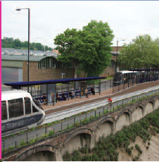 | - Two 40 metre bus stop with a ramp between reducing the width of the Cumberland Road for the SS Great Britain stop (plan 113)! A ramp for the BRT to be able to get onto the road (plan 114)! This will cause a huge build up of traffic on the Cumberland Road since the bus stop already protrudes onto the carriageway, and cars will not be able to pass due to its length. The road is too narrow.  - The location of this stop at Mardyke Ferry Road which is 225 metres from Gas Ferry Road- the road to the SS Great Britain. The pedestrian then has another 175 metres to walk. The 506 bus has a stop in Gas Ferry Road! Car parking along the Cumberland Road is also lost.
- The guided concrete track along the 2.5mile segregated section from the Long Ashton Park and Ride to the Arnolfini is not continuous. It is divided into nine guided and ten unguided sections with four one way sections each with traffic lights so it seems pointless to run along the heritage railway.
- The Design and Access Statement provided by the Rapid Transit Scheme (part shown in Appendix D) sums everything up. Virtually everything has an adverse effect. Why is it being relentlessly pushed on?
- I support improved bus travel. Bus services would substantially improve if we have an Integrated Transport Authority to ensure the City gets the best value out of all the money so far invested in showcase routes. Cross-ticketing and smartcards, more reliable real time information plus closer and more integrated working with bus operators would have more benefits for far more bus passengers at a far lower cost than BRT.
- But I also support a better experience for motorists, who are now told to drive along Coronation Road or Hotwell Road, neither of which can afford the extra traffic. Cumberland Road supports a large number of motorists and a coach parking area. I repeat, Bristol can not afford this sort of money for such a limited, damaging scheme which will further clog up our main arterial roads because a road has been lost to them. Listen to the people in London who have got rid of their bendy buses- and they have wider roads than Bristol. Please preserve our heritage.
- The more one looks at this scheme, the worse it gets.
Maggie Shapland (webmaster and newsletter editor of BIAS) and Roger Davis (secretary of BIAS and volunteer at M Shed)

Appendix 1: letter to Cabinet from Maggie Shapland
97 Princess Victoria Street
Clifton, Bristol BS8 4DD
26 August 2011
Ref: Committee Meeting 1 September 2011
As a member of the committee of the Bristol Industrial Archaeological Society, and resident of Bristol, I wish to protest against the effect that this scheme would have on the heritage railway and the Cumberland Road. M Shed has just been opened at huge cost, the railway is part of the heritage experience for tourists and residents alike. Has no one ever watched the visitors enjoying the experience of the Portbury from Mshed to the Create Centre?
It has been confirmed in the last Cabinet Report that the scheme will have an adverse effect on the railway. The railway track along Cumberland Road will be incorporated into the Ashton Vale concrete bus road and parts will be relaid. How can one incorporate the rapid transit scheme with the heritage railway- the route is not wide enough? One runs on rails, the other on rubber wheels. On high days and holidays which is when the heritage railway is at its most popular, no doubt there will be more pressure to get more rapid transport vehicles running and will take precedence over the heritage railway wanting to use the same route. I am sure visitors would prefer to use the heritage railway.
To not allow cars over Prince St bridge is ridiculous. How are drivers meant to get to the centre if they are driving in from Cumberland Road? How will car drivers get from the centre to M Shed? It will place even more pressure on the other roads such as Hotwell Road. This incredibly expensive scheme will wreck the tourist experience, and make it harder for tourists to get to the centre of Bristol and M shed. The city needs to review its priorities.
The Cumberland Road will lose its valuable coach parking on the south side to a bus lane which is in addition to the rapid transit scheme! Why does one need a dedicated bus lane here? Parts of the Cumberland Road seem to be only for Rapid Transit vehicles!
if you have spoilt a tourist attraction then less people will visit because there is less to visit it for and make it harder to get to where you want to go, especially if using a car. This is Bristol- a wonderful city full of heritage. Why not make the most of it rather than destroying it.
Consider Gloucester which is a ghost town compared with what it used to be. Car free city centres are an impossible, impractical dream. Paris, Rome and London already have good transport systems that take you where you want to go. This system is half baked and very expensive and only goes to limited places. By all means put on more buses, add more routes but do not destroy the infrastructure and our heritage by adding an inflexible expensive system like this. The roads are too narrow.
It is not an easily accessible public transport as has been claimed. To get to it from Clifton – a major tourist location, is very tortuous and I can get a bus to Temple Meads or the Centre or Ashton Vale anyway without £42 million needing to be spent. The system is essentially one route from one side of the city to the other, with huge portions of the city left unserved and will lose integration with existing mass-transit systems. I would refute the value of the scheme outweighing the costs of the scheme by threefold. This is total propaganda.
I strongly object to the Council committing to funding the £42 million local contribution to the three major transport schemes consisting of Ashton Vale to Temple Meads and City Centre Bus Rapid Transit Scheme, North Fringe to Hengrove and South Bristol Link. The loss to local amenities during construction will far outweigh the benefits. These are hard financial times yet local businesses and residents are being asked to foot the bill. Businesses will move out if they have to pay a levy. Bristol can not afford this sort of money for such a limited, damaging scheme which will clog up our main arterial roads.
Maggie Shapland

Appendix 2: Response from Tim Kent 10 October 2011
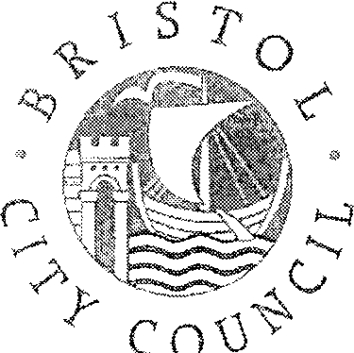
Ms Maggie Shapland
By email: Maggie.shapland@googlemail.com
Reply to Telephone, O1179222879
Fax
E-mail Tim.Kent@bristoI.qov.uk
Our ref
Your ref Date 10 October 2011
Dear Ms Shapland

Thank you for your statement.

You also raise a number of questions, my response to which follows.

The inbound BRT alignment is shared with the Bristol Harbour Railway alongside Cumberland Road. The alignment is wide enough to accommodate both modes. Rails will be incorporated into the BRT guideway to allow operation of the railway. Outbound BRT will use a new bus lane on Cumberland Road. The bus lane is being provided in order to maximise reliability of the rapid transit and other North Somerset bus services, On days when the railway is operating, bus services will use Cumberland Road.
Prohibition of general traffic from Prince Street Bridge is necessary to maintain reliability of rapid transit services, The upstream side of the bridge will incorporate guidance and thus physically prohibit other vehicles, If the BRT proposals are implemented, the number of people (pedestrians, cyclists and on BRT) forecast to use the bridge in peak periods will be greater than the number of current users and by more sustainable modes.
You ask how, in these circumstances, drivers are meant to get to the city centre if they are driving in from Cumberland Road. If their origin is from Spike Island or elsewhere on Cumberland Road, then the choice is either via Cumberland Basin/Hotwell Road or via Redcliffe Hill. If their origin is further afield then they will have had opportunities earlier on in their journey to decide where to cross the Floating Harbour and/or New Cut - at Cumberland Basin (thence via Coronation Road or Hotwell Road) or at Bedminster Bridge -thus avoiding using Prince Street Bridge as an inappropriate rat-run. Parking at/for M Shed is very limited so the impact of the Prince Street Bridge proposals will be minimal.
BRT will provide an effective alternative for car users (for whatever purpose tourism/Leisure, work or business) to access the centre of Bristol whether they are local, residents of the sub-region or visitors from further afield, There will be BRT stops at M shed, Arnolfini, the Centre^ Spike Island (for SSGB), CREATE and at tong Ashton Park and Ride as well as serving Temple Meads Railway Station. These will provide services for local residents and business users as well as tourists (particularly from Temple Meads and via the Park and Ride site) from sustainable interchanges and to a variety of tourist attractions,
ClIr Tim Kent
Executive Member for Transport
-
The Council House Colllege Green BS1 5TR

Appendix 3: Report of Strategic Director – Neighbourhoods & City Development to Cabinet 21st July 2011
Report presented before a bid for all three schemes submitted to the Department of Transport by 8th September. This confirms the negative impacts of the proposal.
Appendix D1 Eco Impact Checklist
Effect on The appearance of the city (Page 61).
 | Impact | Mitigation Measures
-ve | Effect on urban edge with impact on open field at Ashton Gate. | Planting to provide visual screening and landscape integration.
-ve | Visual impact at properties in Ashton Vale | Planting to provide visual screening
-ve | Impact of new large scale railway overbridge at Winterstoke Road. | Quality of design and appearance of the bridge structure.
Neutral | Route alongside Brunel Way well screened. | Appropriate planting.
+ve | Ashton Gate Swing Bridge. | Refurbishment of historic structure.
-ve | New signalised junction at Avon Crescent | None.
-ve | Impact on character of Cumberland Basin through introduction of new structures | Design of busway in character using appropriate materials, retention of stone walls and replacement of important railings.
-ve | Effects on heritage railway and character of dockside | Relocation of railway lines and other railway features and use of materials in keeping with existing character.
+ve | Prince Street Bridge | Removal of existing signage and other street clutter
Page 64
The benefits of the scheme are…
- Improve journey times and reliability from the south west of the sub-region to Bristol City Centre and to Bristol Temple Meads Railway Station
- Opportunity to improve connectivity with Bristol International Airport
- Provision of a high quality, more sustainable choice of travel by rapid transit, cycling or walking
- Shift of journeys to more environmentally sustainable transport modes
- Shift of journeys to a safer transport mode
- Improving physical activity and quality of life by encouraging walking and cycling
- Better use of an under-used existing transport corridor and retaining road network capacity
- Refurbishment of historic Ashton Gate Swing Bridge and improvement of appearance of Prince Street Bridge
The significant [adverse] impacts[M1] of this proposal The significant [adverse] impacts[M1] of this proposal are....
- Adverse impacts on the appearance of the city, the heritage railway and dockside
- Slight changes in local air quality, both positive and negative, along the route
- Slight increase in noise due to general increase in traffic, and major impacts at two locations Ashton Vale and the Floating Harbour
- Construction-related nuisances to people due to noise and air quality
- Construction-related impacts on habitats, flora, and fauna

page 72

The proposal for the construction over the New Cut from Bathurst Basin could have a moderate / large negative impact on buried archaeological remains, historic and listed structures, setting of listed buildings and the character of the City Docks Conservation Area. Proposals to alter / strengthen Prince Street Bridge (Grade II Listed Building) could also have implications for the historic fabric and appearance of the structure.

Appendix 4 Rapid Transit Heritage Design and Access Statement
(Deposit Document A19) Summary Table Page 85 Virtually everything assessed had a negative adverse effect!

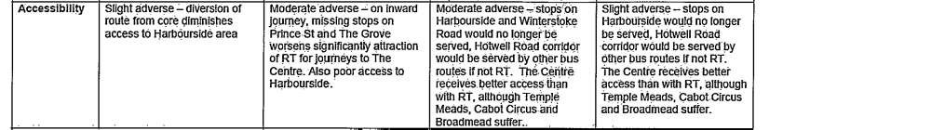
Page 70

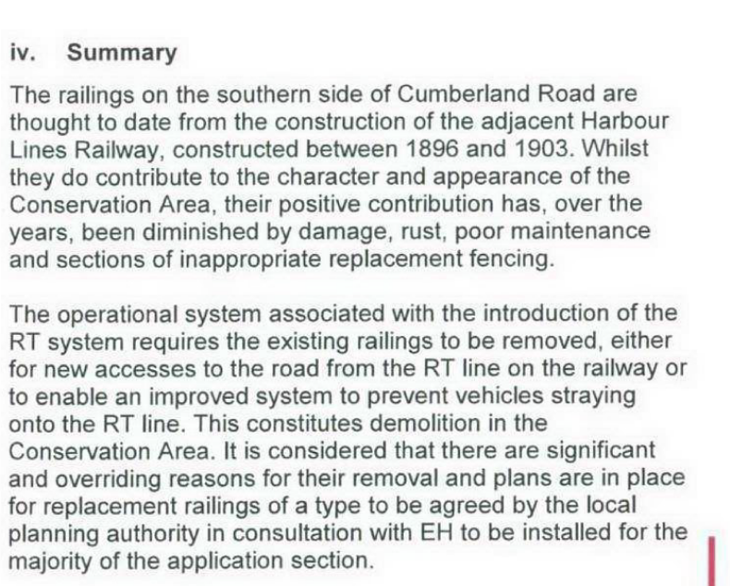

Appendix 5

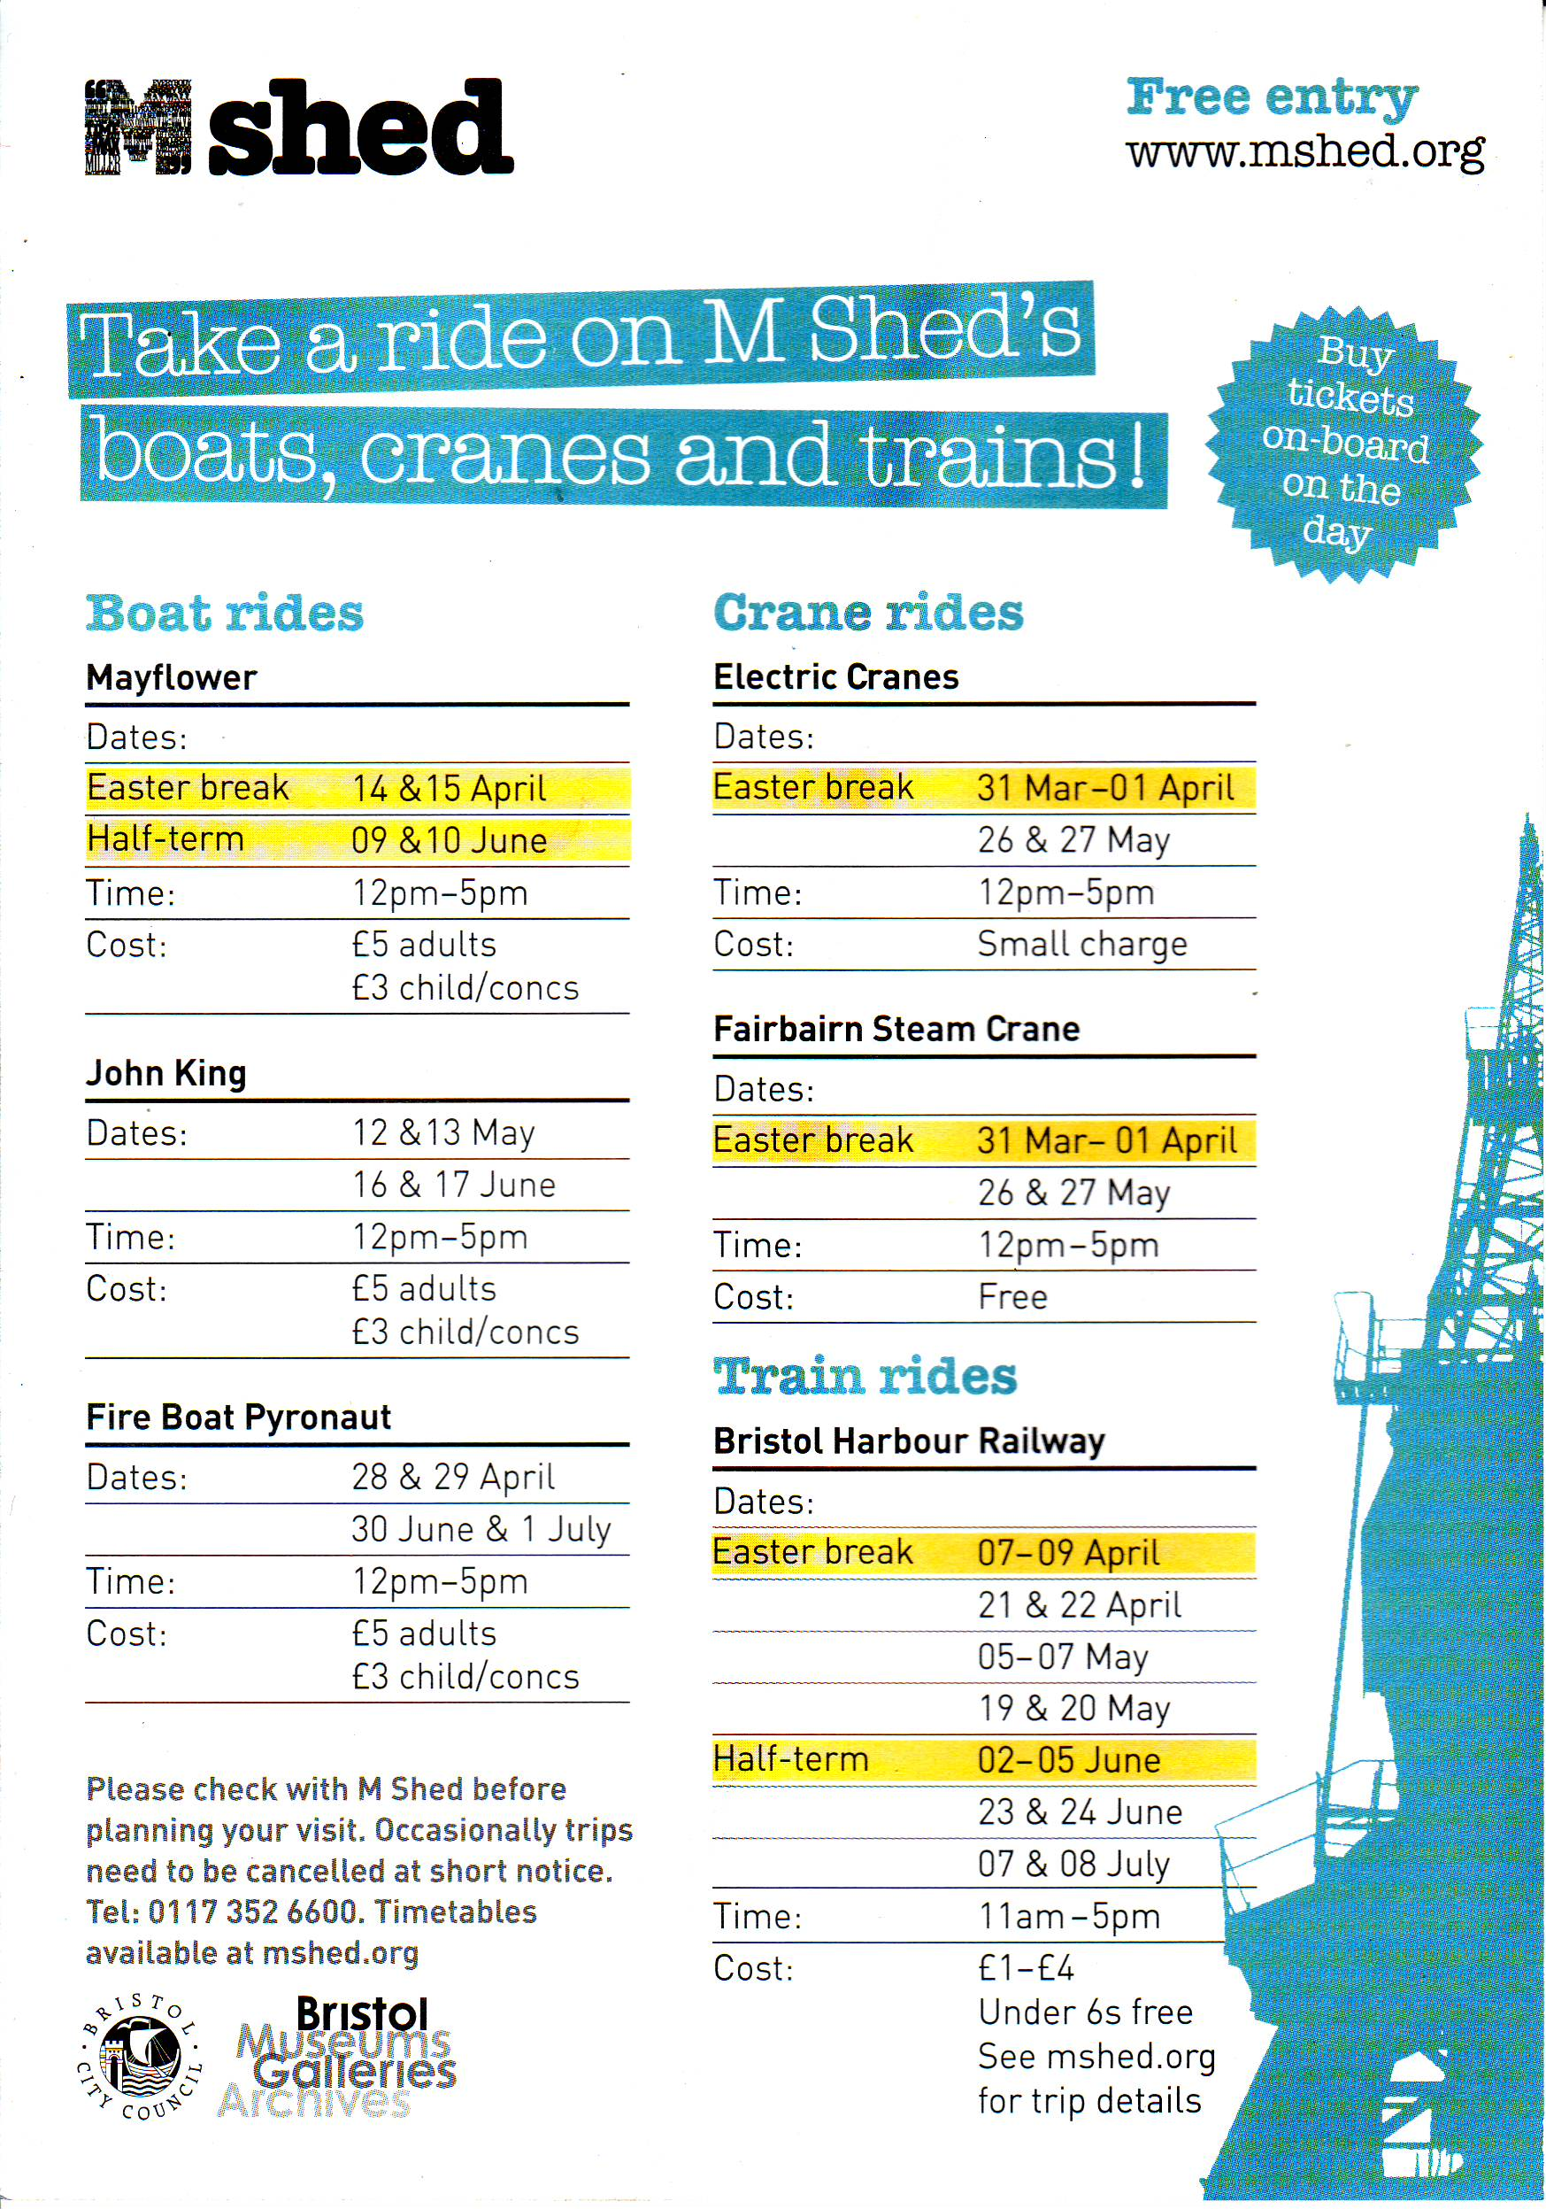

Appendix 6
Shows paucity of long stay coach parking for a city of this size. Currently only 40 spaces north of the river. 12 will be lost.

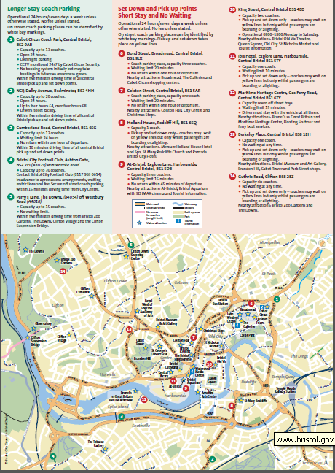

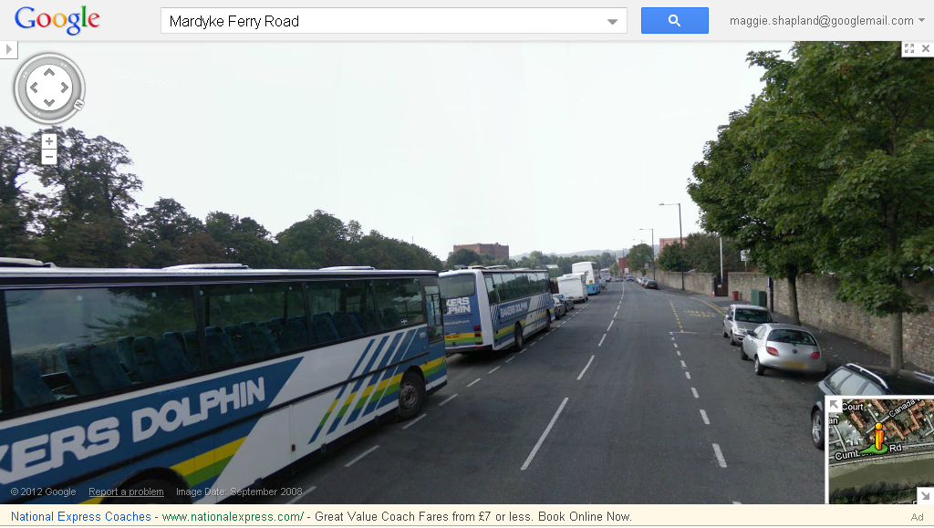

Well used

